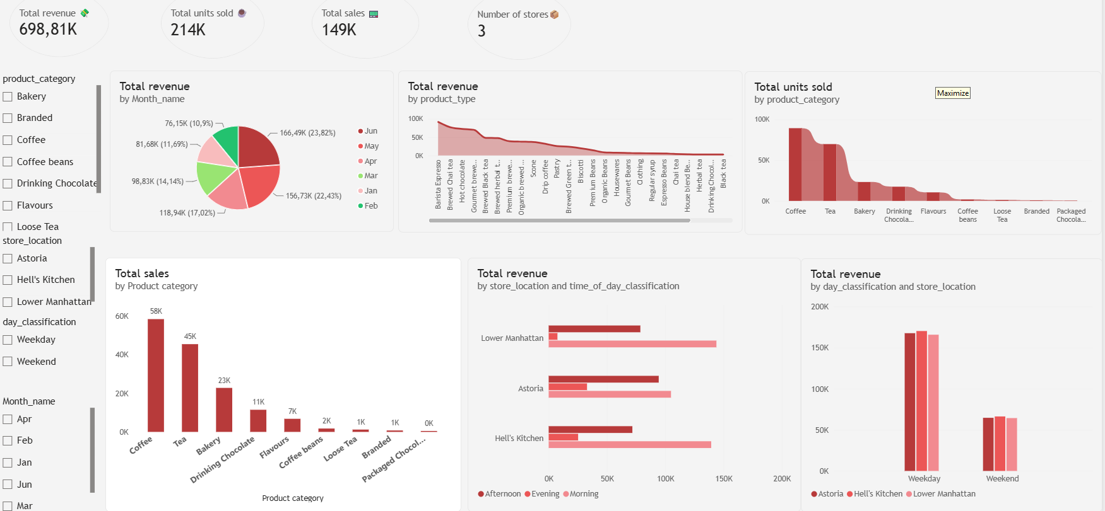
BRIGHT COFFEE PDF DASHBOARD

